Course Code : **CSE 404**

Course Title : **Software Engineering and ISD Laboratory**

**Project Name** : Bus Ticket Booking Management System

**Tutorial**: 1

**Experiment Name**: Tutorial 1 (CT 1) Software Tool Output for Q 1(b), 2 (a, or b),

2(c), 3 (a)

**Submitted To**

**Dr. Mohammad Zahidur Rahman**

Professor

**Dr. Md. Humayun Kabir**

Professor

Department of Computer Science & Engineering

Jahangirnagar University, Savar.

Group No : 02

**Submitted By**

| **Sl** | Class Roll | Name |
| --- | --- | --- |
| 01 | 370 | Prokash Maitra |

**Answer of 1b:**

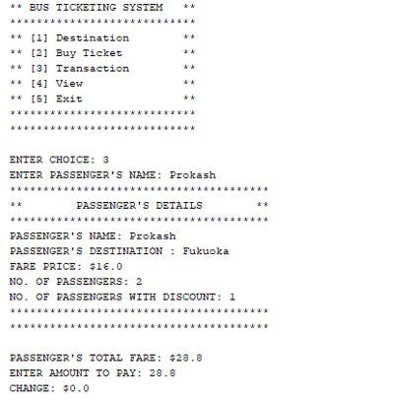**:**

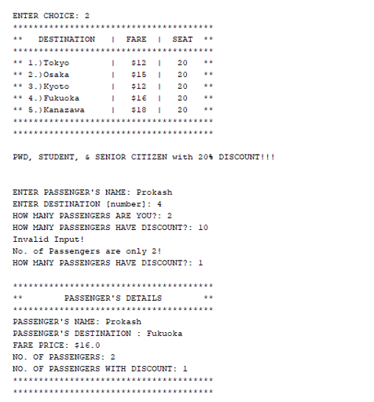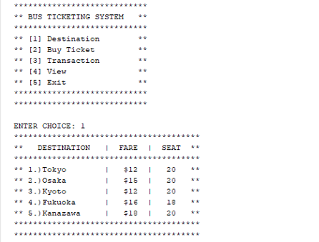

**Answer of 2a:**

**Use case for subsystem 1**

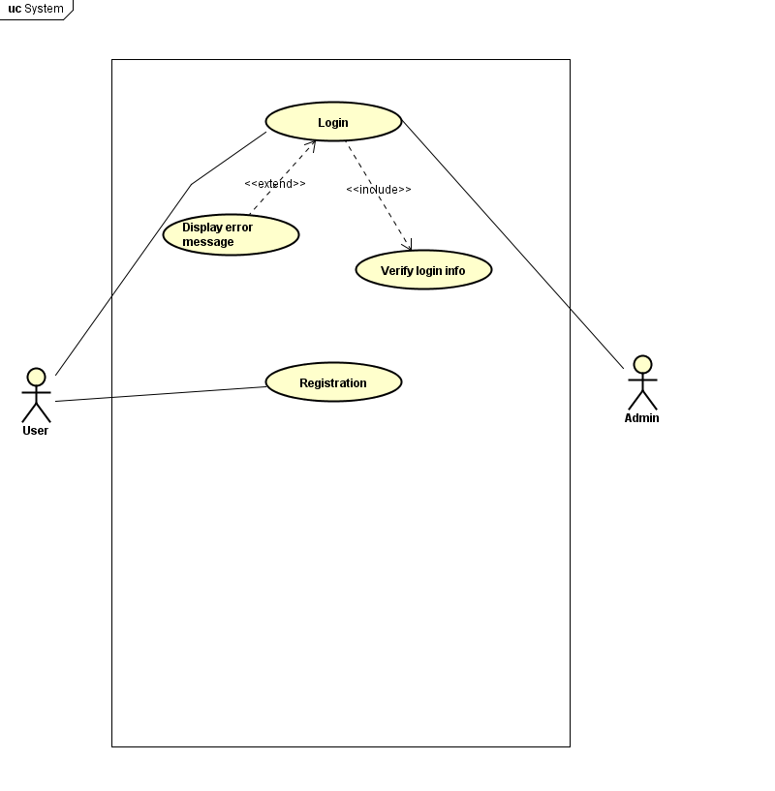

**Use case for subsystem2**

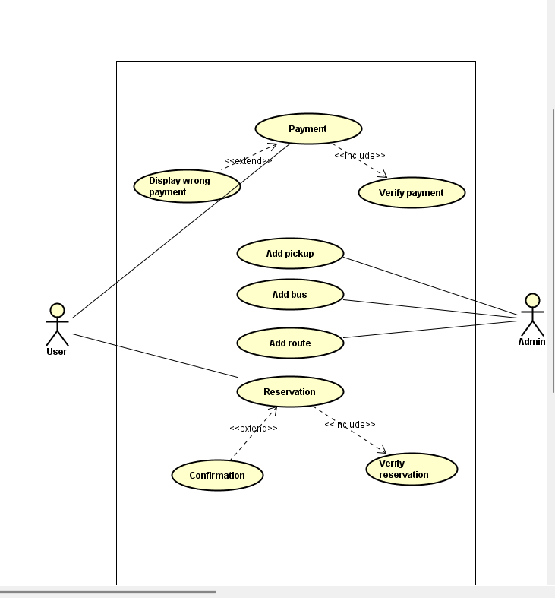

**Answer of 2c**

**Answer of 2c:**

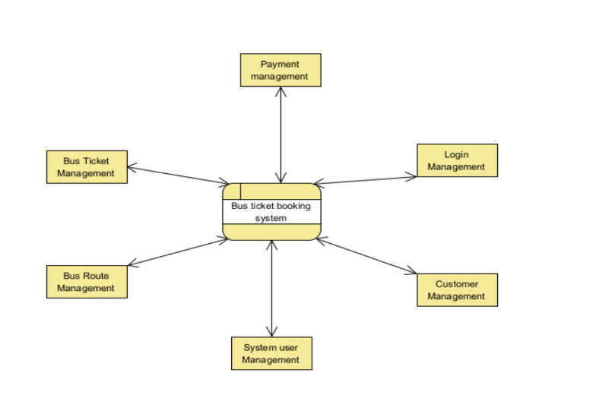

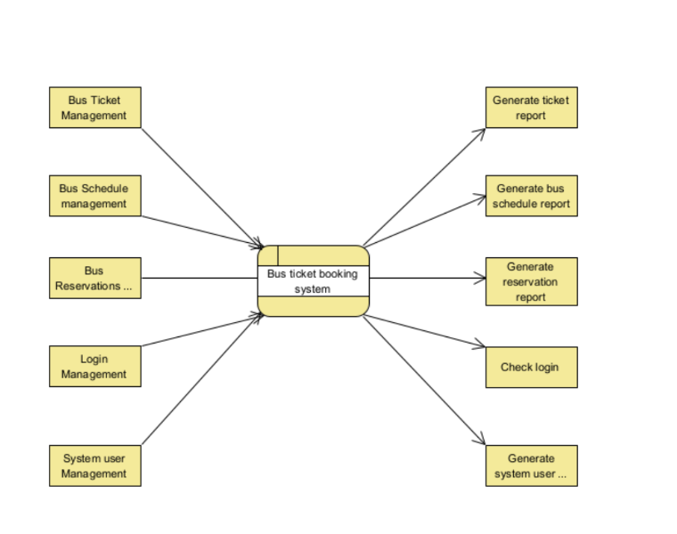

**Answer of 3a:**

